

INDUSTRIAL INTERNSHIP REPORT

TITLE OF THE PROJECT

# Basic Swift in Native IOS

# Degree of Bachelor of Technology(B.Tech)

Submitted By

**Name :-** Ankit Senjaliya

**Enrollment No. :-** 19BT04046

**Branch :-** Computer Science and Engineering

Submitted To

**Name** :- Ms. Avneet Saluja

GSFC University, Vadodara

**GSFC University, Vadodara**

Internship Institution :- Logistic Infotech Pvt Ltd, Rajkot

Internship Period :- 1 Month

Date of Report Submission :- 30th January, 2023

# DECLARATION

I hereby declare that the Industrial Internship Report entitled ("Zippy Application using Swift in IOS") is an authentic record of my own work as requirements of Industrial Internship during the period from **02-01-2023** to **27-01-2023** for the award of degree **B.Tech Computer Science and Engineering**, GSFC University, Vadodara, under the guidance of **Ms. Avneet Saluja**.

**Name of Student :-** Ankit Senjaliya

**Enrollment No. :-** 19BT04046

**Date :-** 30th January, 2023 **Signature of Student**

**CERTIFICATE**

This is to certify that **Mr. Ankit Senjaliya** has completed Industrial Internship during the period from **02-01-2023** to **27-01-2023** in our Organization / Industry as a Partial Fulfillment of Degree of **B.Tech Computer Science and Engineering**. He was trained in the field of **IOS Developer**.

### Signature & Seal of Host Company Mentor

## ACKNOWLEDGEMENT

* I have taken efforts in this project. However, it would not have been possible without the kind support and help of many individuals and organisations. I would like to extend my sincere thanks to all of them.
* I am highly indebted to **Mr. Bhavin Bera (IOS Developer)** for their guidance and constant supervision as well as for providing necessary information regarding the project & also for their support in completing the project.
* I would like to express my gratitude towards of **Logistic Infotech, Rajkot** for their kind co-operation and encouragement which help me in completion of this project.
* I would like to express my special gratitude and thanks to industry persons for giving me such attention and time. my thanks and appreciations also go to my colleague in developing the project and people who have willingly helped me out with their abilities."
* It is indeed a great pleasure to express my thanks and gratitude to all those who helped me. No serious and lasting achievement or success one can ever achieve without the help of friendly guidance and co-operation of so many people involved in the work.
* I am very thankful to our guide **Prof. Maulik Parekh,** the person who makes us follow the right steps during project work. I express my deep sense of gratitude for her guidance, suggestions, and expertise at every stage. Apart from that his value and expertise suggestions during the documentation of our report indeed help me a lot.

Thanks to my friends who have been a source of inspiration and motivation that helped me during my project work.

I am heartily thankful to our external guide **Nilesh Kikani** for providing me an opportunity to work over this report and for their endless and great support.

## I am also thankful to my Head Dr. Ashwin Dobariya and Dean Dr. R. Sridaran for their support as and when required. I would like to extend my gratitude towards all who directly or indirectly supported and helped me to accomplish my project work.

## TABLE OF CONTENT

|  |  |  |
| --- | --- | --- |
| **Sr. No.** | **Title** | **Pg. no.** |
| 1 | Declaration | 2 |
| 2 | Certificate | 3 |
| 3 | Acknowledgment | 5 |
| 4 | Table of Content | 6 |
| 5 | Abstract | 7 |
| 6 | Keywords | 7 |
| 7 | Chapter: 1 Introduction of Swift | 8 |
|  | Chapter: 2 Swift Components | 11 |
|  | Chapter: 3 Tools and Technology used | 20 |
|  | Chapter: 4 Observations | 21 |
|  | Chapter: 5 Conclusion | 22 |
| 14 | References | 23 |

**ABSTRACT**

The development of information and communication technologies also develops programming languages

and development tools. Swift programming language is one of many emerging languages. The language was

primarily designed for developing applications for iOS and macOS. Gradually, Swift becomes the primary language

for developing iOS mobile apps. This paper describes the essential features, advantages and disadvantages of the

Swift programming language and compares it with other languages. The article shows some measurement results

and a comparison of Swift program speeds and some other programming languages. We find out from the tracking

of students' work and practical projects that working with Swift is often faster, brighter and safer than the previously

used Objective-C language. The article describes the results of the survey among students and demonstrates the

advantages of language in the field of programming teaching. Another goal of the article is to show the possibilities,

advantages and limitations of Swift's programming language in the development of mobile applications. The paper

also shows the possibilities of Swift language in teaching

The development of information and communication technologies also develops programming languages

and development tools. Swift programming language is one of many emerging languages. The language was

primarily designed for developing applications for iOS and macOS. Gradually, Swift becomes the primary language

for developing iOS mobile apps. This paper describes the essential features, advantages and disadvantages of the

Swift programming language and compares it with other languages. The article shows some measurement results

and a comparison of Swift program speeds and some other programming languages. We find out from the tracking

of students' work and practical projects that working with Swift is often faster, brighter and safer than the previously

used Objective-C language. The article describes the results of the survey among students and demonstrates the

advantages of language in the field of programming teaching. Another goal of the article is to show the possibilities,

advantages and limitations of Swift's programming language in the development of mobile applications. The paper

also shows the possibilities of Swift language in teaching

The development of information and communication technologies also develops programming languages

and development tools. Swift programming language is one of many emerging languages. The language was

primarily designed for developing applications for iOS and macOS. Gradually, Swift becomes the primary language

for developing iOS mobile apps. This paper describes the essential features, advantages and disadvantages of the

Swift programming language and compares it with other languages. The article shows some measurement results

and a comparison of Swift program speeds and some other programming languages. We find out from the tracking

of students' work and practical projects that working with Swift is often faster, brighter and safer than the previously

used Objective-C language. The article describes the results of the survey among students and demonstrates the

advantages of language in the field of programming teaching. Another goal of the article is to show the possibilities,

advantages and limitations of Swift's programming language in the development of mobile applications. The paper

also shows the possibilities of Swift language in teaching

The development of information and communication technologies also develops programming languages

and development tools. Swift programming language is one of many emerging languages. The language was

primarily designed for developing applications for iOS and macOS. Gradually, Swift becomes the primary language

for developing iOS mobile apps. This paper describes the essential features, advantages and disadvantages of the

Swift programming language and compares it with other languages. The article shows some measurement results

and a comparison of Swift program speeds and some other programming languages. We find out from the tracking

of students' work and practical projects that working with Swift is often faster, brighter and safer than the previously

used Objective-C language. The article describes the results of the survey among students and demonstrates the

advantages of language in the field of programming teaching. Another goal of the article is to show the possibilities,

advantages and limitations of Swift's programming language in the development of mobile applications. The paper

also shows the possibilities of Swift language in teaching

The development of information and communication technologies also develops programming languages

and development tools. Swift programming language is one of many emerging languages. The language was

primarily designed for developing applications for iOS and macOS. Gradually, Swift becomes the primary language

for developing iOS mobile apps. This paper describes the essential features, advantages and disadvantages of the

Swift programming language and compares it with other languages. The article shows some measurement results

and a comparison of Swift program speeds and some other programming languages. We find out from the tracking

of students' work and practical projects that working with Swift is often faster, brighter and safer than the previously

used Objective-C language. The article describes the results of the survey among students and demonstrates the

advantages of language in the field of programming teaching. Another goal of the article is to show the possibilities,

advantages and limitations of Swift's programming language in the development of mobile applications. The paper

also shows the possibilities of Swift language in teaching

The development of information and communication technologies also develops programming languages

and development tools. Swift programming language is one of many emerging languages. The language was

primarily designed for developing applications for iOS and macOS. Gradually, Swift becomes the primary language

for developing iOS mobile apps. This paper describes the essential features, advantages and disadvantages of the

Swift programming language and compares it with other languages. The article shows some measurement results

and a comparison of Swift program speeds and some other programming languages. We find out from the tracking

of students' work and practical projects that working with Swift is often faster, brighter and safer than the previously

used Objective-C language. The article describes the results of the survey among students and demonstrates the

advantages of language in the field of programming teaching. Another goal of the article is to show the possibilities,

advantages and limitations of Swift's programming language in the development of mobile applications. The paper

also shows the possibilities of Swift language in teaching

The development of information and communication technologies also develops programming languages

and development tools. Swift programming language is one of many emerging languages. The language was

primarily designed for developing applications for iOS and macOS. Gradually, Swift becomes the primary language

for developing iOS mobile apps. This paper describes the essential features, advantages and disadvantages of the

Swift programming language and compares it with other languages. The article shows some measurement results

and a comparison of Swift program speeds and some other programming languages. We find out from the tracking

of students' work and practical projects that working with Swift is often faster, brighter and safer than the previously

used Objective-C language. The article describes the results of the survey among students and demonstrates the

advantages of language in the field of programming teaching. Another goal of the article is to show the possibilities,

advantages and limitations of Swift's programming language in the development of mobile applications. The paper

also shows the possibilities of Swift language in teaching

The development of information and communication technologies also develops programming languages

and development tools. Swift programming language is one of many emerging languages. The language was

primarily designed for developing applications for iOS and macOS. Gradually, Swift becomes the primary language

for developing iOS mobile apps. This paper describes the essential features, advantages and disadvantages of the

Swift programming language and compares it with other languages. The article shows some measurement results

and a comparison of Swift program speeds and some other programming languages. We find out from the tracking

of students' work and practical projects that working with Swift is often faster, brighter and safer than the previously

used Objective-C language. The article describes the results of the survey among students and demonstrates the

advantages of language in the field of programming teaching. Another goal of the article is to show the possibilities,

advantages and limitations of Swift's programming language in the development of mobile applications. The paper

also shows the possibilities of Swift language in teaching

The development of information and communication technologies also develops programming languages

and development tools. Swift programming language is one of many emerging languages. The language was

primarily designed for developing applications for iOS and macOS. Gradually, Swift becomes the primary language

for developing iOS mobile apps. This paper describes the essential features, advantages and disadvantages of the

Swift programming language and compares it with other languages. The article shows some measurement results

and a comparison of Swift program speeds and some other programming languages. We find out from the tracking

of students' work and practical projects that working with Swift is often faster, brighter and safer than the previously

used Objective-C language. The article describes the results of the survey among students and demonstrates the

advantages of language in the field of programming teaching. Another goal of the article is to show the possibilities,

advantages and limitations of Swift's programming language in the development of mobile applications. The paper

also shows the possibilities of Swift language in teaching

The development of information and communication technologies also develops programming languages

and development tools. Swift programming language is one of many emerging languages. The language was

primarily designed for developing applications for iOS and macOS. Gradually, Swift becomes the primary language

for developing iOS mobile apps. This paper describes the essential features, advantages and disadvantages of the

Swift programming language and compares it with other languages. The article shows some measurement results

and a comparison of Swift program speeds and some other programming languages. We find out from the tracking

of students' work and practical projects that working with Swift is often faster, brighter and safer than the previously

used Objective-C language. The article describes the results of the survey among students and demonstrates the

advantages of language in the field of programming teaching. Another goal of the article is to show the possibilities,

advantages and limitations of Swift's programming language in the development of mobile applications. The paper

also shows the possibilities of Swift language in teaching

The development of information and communication technologies also develops programming languages

and development tools. Swift programming language is one of many emerging languages. The language was

primarily designed for developing applications for iOS and macOS. Gradually, Swift becomes the primary language

for developing iOS mobile apps. This paper describes the essential features, advantages and disadvantages of the

Swift programming language and compares it with other languages. The article shows some measurement results

and a comparison of Swift program speeds and some other programming languages. We find out from the tracking

of students' work and practical projects that working with Swift is often faster, brighter and safer than the previously

used Objective-C language. The article describes the results of the survey among students and demonstrates the

advantages of language in the field of programming teaching. Another goal of the article is to show the possibilities,

advantages and limitations of Swift's programming language in the development of mobile applications. The paper

also shows the possibilities of Swift language in teaching

**The development of information and communication technologies also develops programming languages and development tools. Swift programming language is one of many emerging languages. The language was primarily designed for developing applications for iOS and macOS. Gradually, Swift becomes the primary language for developing iOS mobile apps. This paper describes the essential features, advantages and disadvantages of the Swift programming language and compares it with other languages. The article shows some measurement results and a comparison of Swift program speeds and some other programming languages. We find out from the tracking of students' work and practical projects that working with Swift is often faster, brighter and safer than the previously used Objective-C language. The article describes the results of the survey among students and demonstrates the advantages of language in the field of programming teaching. Another goal of the article is to show the possibilities, advantages and limitations of Swift's programming language in the development of mobile applications. The paper also shows the possibilities of Swift language in teaching** The development of information and communication technologies also develops programming languages

and development tools. Swift programming language is one of many emerging languages. The language was

primarily designed for developing applications for iOS and macOS. Gradually, Swift becomes the primary language

for developing iOS mobile apps. This paper describes the essential features, advantages and disadvantages of the

Swift programming language and compares it with other languages. The article shows some measurement results

and a comparison of Swift program speeds and some other programming languages. We find out from the tracking

of students' work and practical projects that working with Swift is often faster, brighter and safer than the previously

used Objective-C language. The article describes the results of the survey among students and demonstrates the

advantages of language in the field of programming teaching. Another goal of the article is to show the possibilities,

advantages and limitations of Swift's programming language in the development of mobile applications. The paper

also shows the possibilities of Swift language in teaching

The development of information and communication technologies also develops programming languages

and development tools. Swift programming language is one of many emerging languages. The language was

primarily designed for developing applications for iOS and macOS. Gradually, Swift becomes the primary language

for developing iOS mobile apps. This paper describes the essential features, advantages and disadvantages of the

Swift programming language and compares it with other languages. The article shows some measurement results

and a comparison of Swift program speeds and some other programming languages. We find out from the tracking

of students' work and practical projects that working with Swift is often faster, brighter and safer than the previously

used Objective-C language. The article describes the results of the survey among students and demonstrates the

advantages of language in the field of programming teaching. Another goal of the article is to show the possibilities,

advantages and limitations of Swift's programming language in the development of mobile applications. The paper

also shows the possibilities of Swift language in teaching

The development of information and communication technologies also develops programming languages

and development tools. Swift programming language is one of many emerging languages. The language was

primarily designed for developing applications for iOS and macOS. Gradually, Swift becomes the primary language

for developing iOS mobile apps. This paper describes the essential features, advantages and disadvantages of the

Swift programming language and compares it with other languages. The article shows some measurement results

and a comparison of Swift program speeds and some other programming languages. We find out from the tracking

of students' work and practical projects that working with Swift is often faster, brighter and safer than the previously

used Objective-C language. The article describes the results of the survey among students and demonstrates the

advantages of language in the field of programming teaching. Another goal of the article is to show the possibilities,

advantages and limitations of Swift's programming language in the development of mobile applications. The paper

also shows the possibilities of Swift language in teaching

The development of information and communication technologies also develops programming languages

and development tools. Swift programming language is one of many emerging languages. The language was

primarily designed for developing applications for iOS and macOS. Gradually, Swift becomes the primary language

for developing iOS mobile apps. This paper describes the essential features, advantages and disadvantages of the

Swift programming language and compares it with other languages. The article shows some measurement results

and a comparison of Swift program speeds and some other programming languages. We find out from the tracking

of students' work and practical projects that working with Swift is often faster, brighter and safer than the previously

used Objective-C language. The article describes the results of the survey among students and demonstrates the

advantages of language in the field of programming teaching. Another goal of the article is to show the possibilities,

advantages and limitations of Swift's programming language in the development of mobile applications. The paper

also shows the possibilities of Swift language in teaching

The development of information and communication technologies also develops programming languages

and development tools. Swift programming language is one of many emerging languages. The language was

primarily designed for developing applications for iOS and macOS. Gradually, Swift becomes the primary language

for developing iOS mobile apps. This paper describes the essential features, advantages and disadvantages of the

Swift programming language and compares it with other languages. The article shows some measurement results

and a comparison of Swift program speeds and some other programming languages. We find out from the tracking

of students' work and practical projects that working with Swift is often faster, brighter and safer than the previously

used Objective-C language. The article describes the results of the survey among students and demonstrates the

advantages of language in the field of programming teaching. Another goal of the article is to show the possibilities,

advantages and limitations of Swift's programming language in the development of mobile applications. The paper

also shows the possibilities of Swift language in teaching

The development of information and communication technologies also develops programming languages

and development tools. Swift programming language is one of many emerging languages. The language was

primarily designed for developing applications for iOS and macOS. Gradually, Swift becomes the primary language

for developing iOS mobile apps. This paper describes the essential features, advantages and disadvantages of the

Swift programming language and compares it with other languages. The article shows some measurement results

and a comparison of Swift program speeds and some other programming languages. We find out from the tracking

of students' work and practical projects that working with Swift is often faster, brighter and safer than the previously

used Objective-C language. The article describes the results of the survey among students and demonstrates the

advantages of language in the field of programming teaching. Another goal of the article is to show the possibilities,

advantages and limitations of Swift's programming language in the development of mobile applications. The paper

also shows the possibilities of Swift language in teaching

The development of information and communication technologies also develops programming languages

and development tools. Swift programming language is one of many emerging languages. The language was

primarily designed for developing applications for iOS and macOS. Gradually, Swift becomes the primary language

for developing iOS mobile apps. This paper describes the essential features, advantages and disadvantages of the

Swift programming language and compares it with other languages. The article shows some measurement results

and a comparison of Swift program speeds and some other programming languages. We find out from the tracking

of students' work and practical projects that working with Swift is often faster, brighter and safer than the previously

used Objective-C language. The article describes the results of the survey among students and demonstrates the

advantages of language in the field of programming teaching. Another goal of the article is to show the possibilities,

advantages and limitations of Swift's programming language in the development of mobile applications. The paper

also shows the possibilities of Swift language in teaching

The development of information and communication technologies also develops programming languages

and development tools. Swift programming language is one of many emerging languages. The language was

primarily designed for developing applications for iOS and macOS. Gradually, Swift becomes the primary language

for developing iOS mobile apps. This paper describes the essential features, advantages and disadvantages of the

Swift programming language and compares it with other languages. The article shows some measurement results

and a comparison of Swift program speeds and some other programming languages. We find out from the tracking

of students' work and practical projects that working with Swift is often faster, brighter and safer than the previously

used Objective-C language. The article describes the results of the survey among students and demonstrates the

advantages of language in the field of programming teaching. Another goal of the article is to show the possibilities,

advantages and limitations of Swift's programming language in the development of mobile applications. The paper

also shows the possibilities of Swift language in teaching

The development of information and communication technologies also develops programming languages

and development tools. Swift programming language is one of many emerging languages. The language was

primarily designed for developing applications for iOS and macOS. Gradually, Swift becomes the primary language

for developing iOS mobile apps. This paper describes the essential features, advantages and disadvantages of the

Swift programming language and compares it with other languages. The article shows some measurement results

and a comparison of Swift program speeds and some other programming languages. We find out from the tracking

of students' work and practical projects that working with Swift is often faster, brighter and safer than the previously

used Objective-C language. The article describes the results of the survey among students and demonstrates the

advantages of language in the field of programming teaching. Another goal of the article is to show the possibilities,

advantages and limitations of Swift's programming language in the development of mobile applications. The paper

also shows the possibilities of Swift language in teaching

The development of information and communication technologies also develops programming languages

and development tools. Swift programming language is one of many emerging languages. The language was

primarily designed for developing applications for iOS and macOS. Gradually, Swift becomes the primary language

for developing iOS mobile apps. This paper describes the essential features, advantages and disadvantages of the

Swift programming language and compares it with other languages. The article shows some measurement results

and a comparison of Swift program speeds and some other programming languages. We find out from the tracking

of students' work and practical projects that working with Swift is often faster, brighter and safer than the previously

used Objective-C language. The article describes the results of the survey among students and demonstrates the

advantages of language in the field of programming teaching. Another goal of the article is to show the possibilities,

advantages and limitations of Swift's programming language in the development of mobile applications. The paper

also shows the possibilities of Swift language in teaching

The development of information and communication technologies also develops programming languages

and development tools. Swift programming language is one of many emerging languages. The language was

primarily designed for developing applications for iOS and macOS. Gradually, Swift becomes the primary language

for developing iOS mobile apps. This paper describes the essential features, advantages and disadvantages of the

Swift programming language and compares it with other languages. The article shows some measurement results

and a comparison of Swift program speeds and some other programming languages. We find out from the tracking

of students' work and practical projects that working with Swift is often faster, brighter and safer than the previously

used Objective-C language. The article describes the results of the survey among students and demonstrates the

advantages of language in the field of programming teaching. Another goal of the article is to show the possibilities,

advantages and limitations of Swift's programming language in the development of mobile applications. The paper

also shows the possibilities of Swift language in teaching

The development of information and communication technologies also develops programming languages

and development tools. Swift programming language is one of many emerging languages. The language was

primarily designed for developing applications for iOS and macOS. Gradually, Swift becomes the primary language

for developing iOS mobile apps. This paper describes the essential features, advantages and disadvantages of the

Swift programming language and compares it with other languages. The article shows some measurement results

and a comparison of Swift program speeds and some other programming languages. We find out from the tracking

of students' work and practical projects that working with Swift is often faster, brighter and safer than the previously

used Objective-C language. The article describes the results of the survey among students and demonstrates the

advantages of language in the field of programming teaching. Another goal of the article is to show the possibilities,

advantages and limitations of Swift's programming language in the development of mobile applications. The paper

also shows the possibilities of Swift language in teaching

The development of information and communication technologies also develops programming languages

and development tools. Swift programming language is one of many emerging languages. The language was

primarily designed for developing applications for iOS and macOS. Gradually, Swift becomes the primary language

for developing iOS mobile apps. This paper describes the essential features, advantages and disadvantages of the

Swift programming language and compares it with other languages. The article shows some measurement results

and a comparison of Swift program speeds and some other programming languages. We find out from the tracking

of students' work and practical projects that working with Swift is often faster, brighter and safer than the previously

used Objective-C language. The article describes the results of the survey among students and demonstrates the

advantages of language in the field of programming teaching. Another goal of the article is to show the possibilities,

advantages and limitations of Swift's programming language in the development of mobile applications. The paper

also shows the possibilities of Swift language in teaching

The development of information and communication technologies also develops programming languages

and development tools. Swift programming language is one of many emerging languages. The language was

primarily designed for developing applications for iOS and macOS. Gradually, Swift becomes the primary language

for developing iOS mobile apps. This paper describes the essential features, advantages and disadvantages of the

Swift programming language and compares it with other languages. The article shows some measurement results

and a comparison of Swift program speeds and some other programming languages. We find out from the tracking

of students' work and practical projects that working with Swift is often faster, brighter and safer than the previously

used Objective-C language. The article describes the results of the survey among students and demonstrates the

advantages of language in the field of programming teaching. Another goal of the article is to show the possibilities,

advantages and limitations of Swift's programming language in the development of mobile applications. The paper

also shows the possibilities of Swift language in teaching

The development of information and communication technologies also develops programming languages

and development tools. Swift programming language is one of many emerging languages. The language was

primarily designed for developing applications for iOS and macOS. Gradually, Swift becomes the primary language

for developing iOS mobile apps. This paper describes the essential features, advantages and disadvantages of the

Swift programming language and compares it with other languages. The article shows some measurement results

and a comparison of Swift program speeds and some other programming languages. We find out from the tracking

of students' work and practical projects that working with Swift is often faster, brighter and safer than the previously

used Objective-C language. The article describes the results of the survey among students and demonstrates the

advantages of language in the field of programming teaching. Another goal of the article is to show the possibilities,

advantages and limitations of Swift's programming language in the development of mobile applications. The paper

also shows the possibilities of Swift language in teaching

The development of information and communication technologies also develops programming languages

and development tools. Swift programming language is one of many emerging languages. The language was

primarily designed for developing applications for iOS and macOS. Gradually, Swift becomes the primary language

for developing iOS mobile apps. This paper describes the essential features, advantages and disadvantages of the

Swift programming language and compares it with other languages. The article shows some measurement results

and a comparison of Swift program speeds and some other programming languages. We find out from the tracking

of students' work and practical projects that working with Swift is often faster, brighter and safer than the previously

used Objective-C language. The article describes the results of the survey among students and demonstrates the

advantages of language in the field of programming teaching. Another goal of the article is to show the possibilities,

advantages and limitations of Swift's programming language in the development of mobile applications. The paper

also shows the possibilities of Swift language in teaching

The development of information and communication technologies also develops programming languages

and development tools. Swift programming language is one of many emerging languages. The language was

primarily designed for developing applications for iOS and macOS. Gradually, Swift becomes the primary language

for developing iOS mobile apps. This paper describes the essential features, advantages and disadvantages of the

Swift programming language and compares it with other languages. The article shows some measurement results

and a comparison of Swift program speeds and some other programming languages. We find out from the tracking

of students' work and practical projects that working with Swift is often faster, brighter and safer than the previously

used Objective-C language. The article describes the results of the survey among students and demonstrates the

advantages of language in the field of programming teaching. Another goal of the article is to show the possibilities,

advantages and limitations of Swift's programming language in the development of mobile applications. The paper

also shows the possibilities of Swift language in teaching

The development of information and communication technologies also develops programming languages

and development tools. Swift programming language is one of many emerging languages. The language was

primarily designed for developing applications for iOS and macOS. Gradually, Swift becomes the primary language

for developing iOS mobile apps. This paper describes the essential features, advantages and disadvantages of the

Swift programming language and compares it with other languages. The article shows some measurement results

and a comparison of Swift program speeds and some other programming languages. We find out from the tracking

of students' work and practical projects that working with Swift is often faster, brighter and safer than the previously

used Objective-C language. The article describes the results of the survey among students and demonstrates the

advantages of language in the field of programming teaching. Another goal of the article is to show the possibilities,

advantages and limitations of Swift's programming language in the development of mobile applications. The paper

also shows the possibilities of Swift language in teaching

The development of information and communication technologies also develops programming languages

and development tools. Swift programming language is one of many emerging languages. The language was

primarily designed for developing applications for iOS and macOS. Gradually, Swift becomes the primary language

for developing iOS mobile apps. This paper describes the essential features, advantages and disadvantages of the

Swift programming language and compares it with other languages. The article shows some measurement results

and a comparison of Swift program speeds and some other programming languages. We find out from the tracking

of students' work and practical projects that working with Swift is often faster, brighter and safer than the previously

used Objective-C language. The article describes the results of the survey among students and demonstrates the

advantages of language in the field of programming teaching. Another goal of the article is to show the possibilities,

advantages and limitations of Swift's programming language in the development of mobile applications. The paper

also shows the possibilities of Swift language in teaching

The development of information and communication technologies also develops programming languages

and development tools. Swift programming language is one of many emerging languages. The language was

primarily designed for developing applications for iOS and macOS. Gradually, Swift becomes the primary language

for developing iOS mobile apps. This paper describes the essential features, advantages and disadvantages of the

Swift programming language and compares it with other languages. The article shows some measurement results

and a comparison of Swift program speeds and some other programming languages. We find out from the tracking

of students' work and practical projects that working with Swift is often faster, brighter and safer than the previously

used Objective-C language. The article describes the results of the survey among students and demonstrates the

advantages of language in the field of programming teaching. Another goal of the article is to show the possibilities,

advantages and limitations of Swift's programming language in the development of mobile applications. The paper

also shows the possibilities of Swift language in teach

* The development of information and communication technologies also develops programming languages and development tools. Swift programming language is one of many emerging languages. The language was primarily designed for developing applications for iOS and macOS.
* Gradually, Swift becomes the primary language for developing iOS mobile apps. This paper describes the essential features, advantages and disadvantages of the Swift programming language and compares it with other languages.
* The article shows some measurement results and a comparison of Swift program speeds and some other programming languages. We find out from the tracking of students' work and practical projects that working with Swift is often faster, brighter and safer than the previously used Objective-C language. The article describes the results of the survey among students and demonstrates the advantages of language in the field of programming teaching.
* Another goal of the article is to show the possibilities, advantages and limitations of Swift's programming language in the development of mobile applications. The paper also shows the possibilities of Swift language in teaching.

**KEYWORDS**

* Comparison of Languages, C++, C#, Education, Java, Objective-C, Programming, Swift

**Chapter: 1 – INTRODUCTION OF SWIFT**

* Swift is a general purpose, multi-paradigm, compiled programming language for developing iOS and OS X tvOS, watchOS applications. It is developed by Apple Inc. It is powerful and intutive language which is easy to learn. Swift code is safe, precise and runs very fast.
* The development of mobile systems and applications requires appropriate programming languages and development tools. First, Objective-C was the primary language for iOS. In recent years, that Objective-C has been shown to cease to meet modern developments.
* That's why Apple has begun to develop the new Swift programming language. It is a compiled programming language for iOS, watchOS, tvOS, macOS, and Linux applications. It was created for more comfortable and safer code creation, but also easier learning programming.
* It is first introduced at Apple’s 2014 Worldwide Developers Conference. Language has undergone dynamic development, and this has occasionally led to problems. Swift brings simpler syntax, shorter code, and safer programs.
* The language is not a purely object-oriented language but is hybrid. Apple says that Swift is 2.6x faster than Objective-C and 8.4x faster than Python. Swift, together with Kotlin, is one of the fastest-growing programming languages.
* Changes include the following areas :-
* Syntax change
* Library and methods names change
* New features integration
* The newly added library like Core ML and AR kit and Vision frameworks
* **Major and promising changes in the latest version**

**i.e., Swift 4 and later includes the following :-**

* Faster, easier to use Strings that retain Unicode correctness and add support for creating, using and managing substrings.
* Smart key paths for type-safe, efficient, extensible key-value coding for Swift types.
* Enhancements to creating and manipulating Dictionary and Set types.
* Extends support of archival and serialization to struct and enum types and enables type-safety for serializing to external formats such as JSON and plist.
* Enforced exclusive access to memory.
* The Swift programming language offers simpler syntax and some constructions than common programming languages. For example, Java provides a large number of collections, some of which have similar properties, and some are currently not recommended. In contrast, Swift offers only essential collections**.**
* Swift 4 is a new programming language developed by Apple Inc for iOS and OS X development. Swift 4 adopts the best of C and Objective-C, without the constraints of C compatibility.
* Swift 4 makes use of safe programming patterns.
* Swift 4 provides modern programming features.
* Swift 4 provides Objective-C like syntax.
* Swift 4 is a fantastic way to write iOS and OS X apps.
* Swift 4 provides seamless access to existing Cocoa frameworks.
* Swift 4 unifies the procedural and object-oriented portions of the language.
* Swift 4 does not need a separate library import to support functionalities like input/output or string handling.
* Swift 4 uses the same runtime as the existing Objective -C system on Mac OS and iOS, which enables Swift 4 programs to run on many existing iOS 6 and OS X 10.8 platforms.
* Swift 4 comes with playground feature where Swift 4 programmers can write their code and execute it to see the results immediately.
* The first public release of Swift was released in 2010. It took **Chris Lattner** almost 14 years to come up with the first official version, and later, it was supported by many other contributors. Swift 4 has been included in Xcode 6 beta.
* Program :-

import UIKit

var str1 = “Hello Ankit!”

var str2 = “How are you?”

print(str1)

print(str2)

* **ADVANTAGES**
* Uses a new, simpler and cleaner syntax.
* A more straightforward syntax leads to faster code creation and control.
* Reducing the number of SDK class reference data has led to more efficient memory usage.
* New features such as Touples, Optionals, Closures, Generics, etc.
* Optional types help to check the existence of an object within the code, which makes it possible to avoid further accidents.
* An open-source language.
* The language is not for the only iOS.
* Swift has already been customised for Linux and used on Android as well.
* **DISADVANTAGES**
* Continuous rapid development and frequent changes.
* Incompatibilities between versions.
* Less choice of libraries and frameworks than other languages.
* Some Cocoa Touch methods yet require Objective-C objects, which complicates the work with Swift.
* Smaller extensions.

**Chapter: 2 – SWIFT COMPONENTS**

* **View** :- A view is an object that is drawn to the screen. It may also contain other views (subviews) that are inside it and move with it.

For example: a text label, a button, a checkbox, a progress bar.

* **View Controller :-** A view controller is not drawable to the screen directly, it manages a group of view objects. View controllers usually have a single view with many subviews.

For example: a screen that shows a list of users, an edit user form, a login screen.

* **Storyboard :-** When we use storyboards, our deployment target should be 5.0 or higher. Storyboards help us create all the screens of an application and interconnect the screens under one interface MainStoryboard.storyboard.
* **Components :-**
* UILabel :- A view that displays one or more lines of informational text.

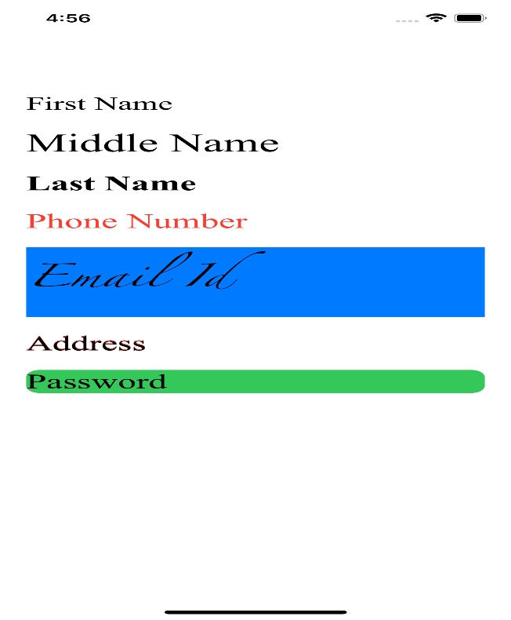

* UIButton :- A control that executes your custom code in response to user interactions.



* UISegmentedControl :- A horizontal control that consists of multiple segments, each segment functioning as a discrete button.

  

* UISlider :- A control for selecting a single value from a continuous range of values.

 

* UIActivityIndicatorView :- A view that shows that a task is in progress.

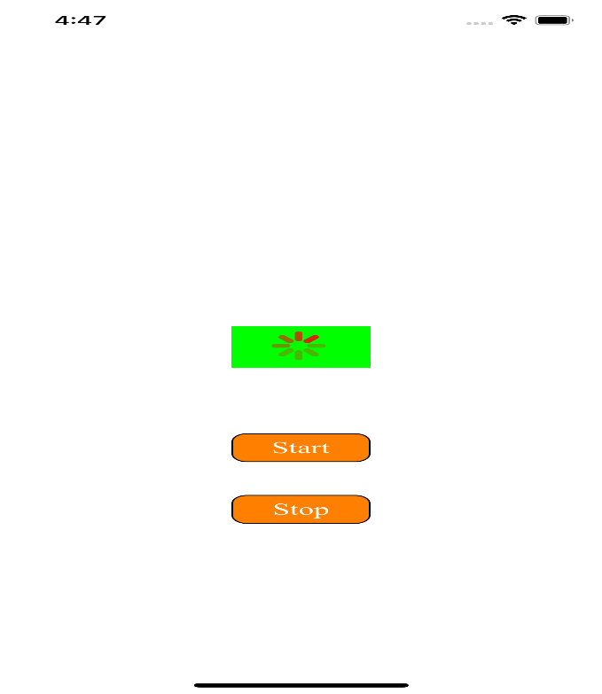 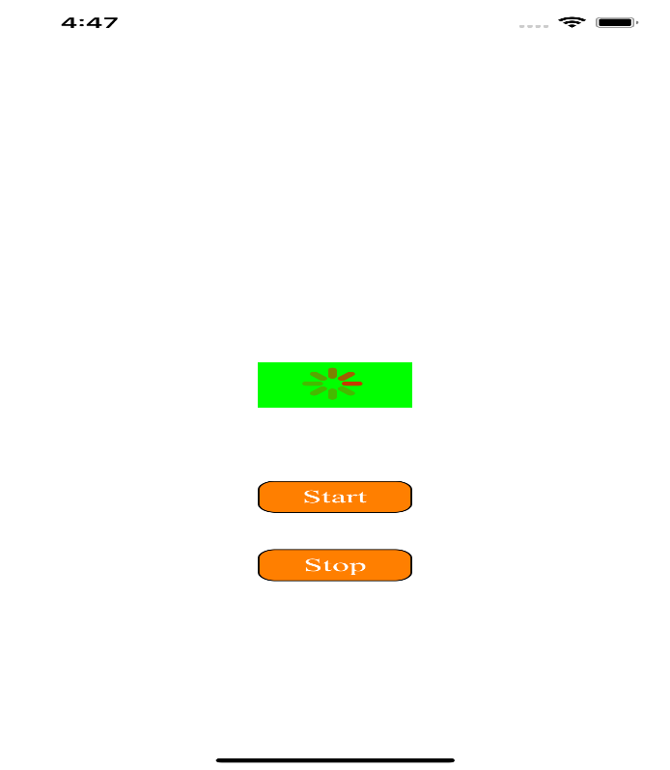

* UISwitch :- A control that offers a binary choice, such as on/off.

 

* UIProgress with timer :- A view that depicts the progress of a task over time.

 

* UIStepper :- A control for incrementing or decrementing a value.

 

* UIImageView :- A view that displays a single image or a sequence of animated images in your interface.



* UITextField (With Delegate) :- An object that displays an editable text area in your interface.

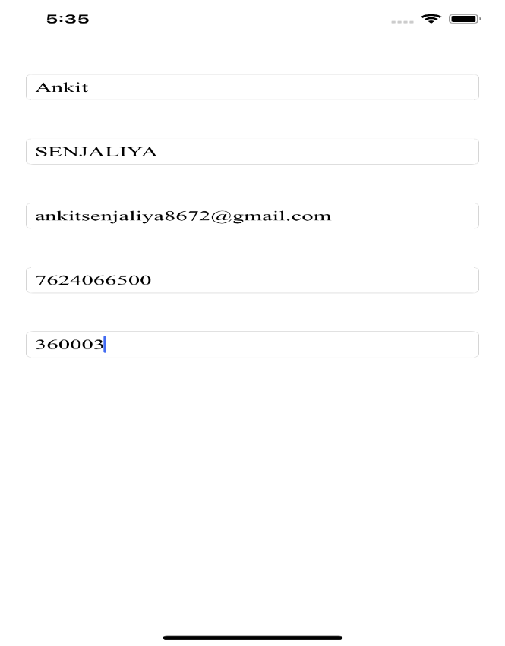 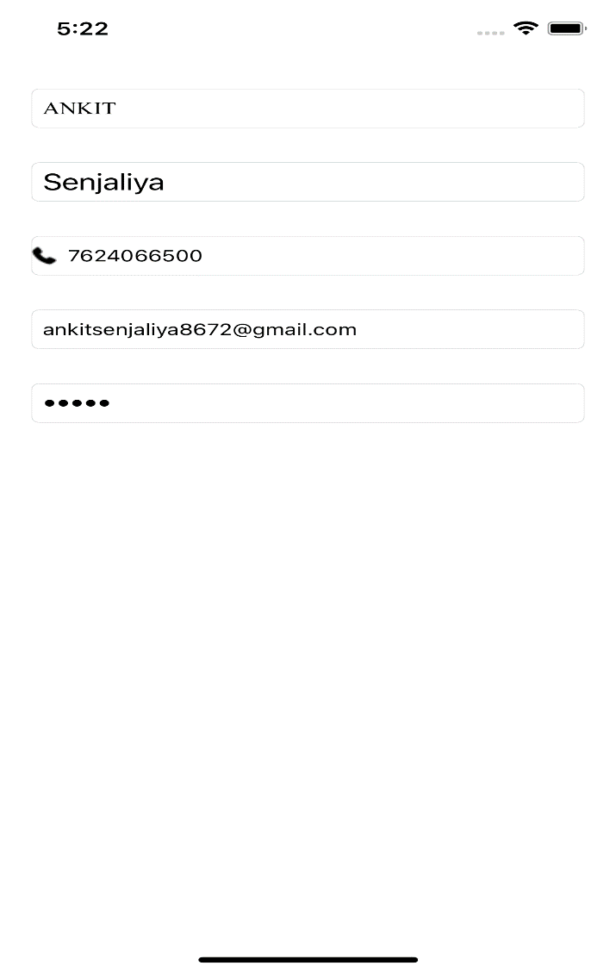

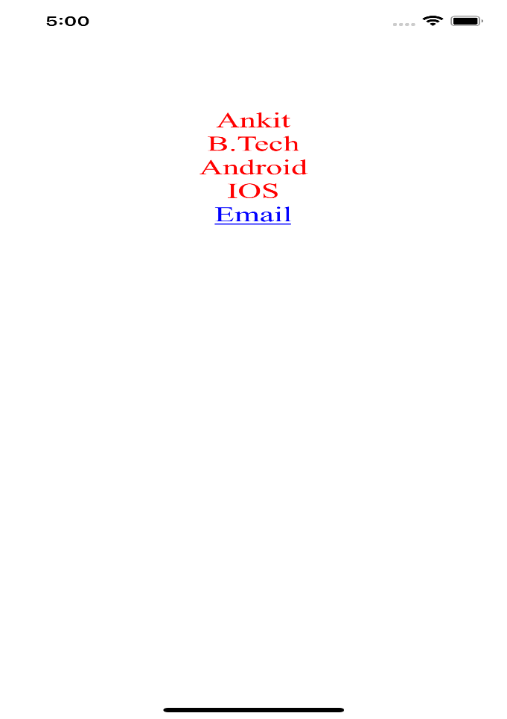

* RGB Slider :-

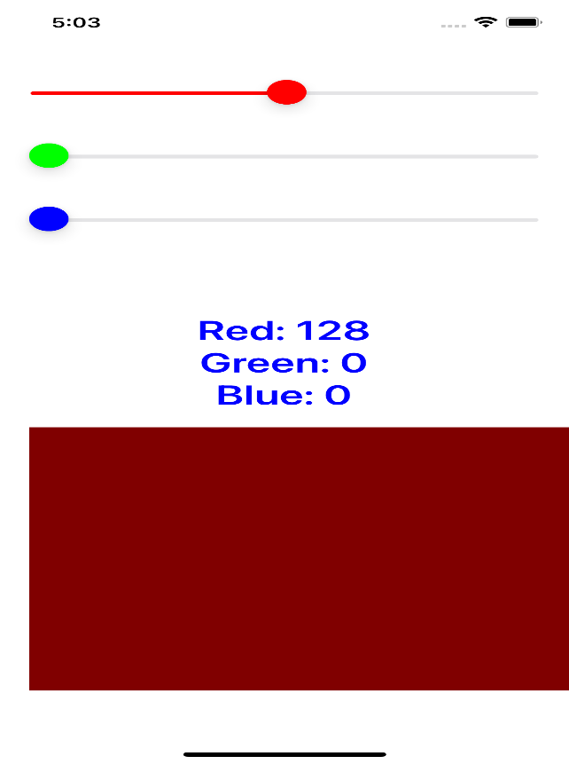 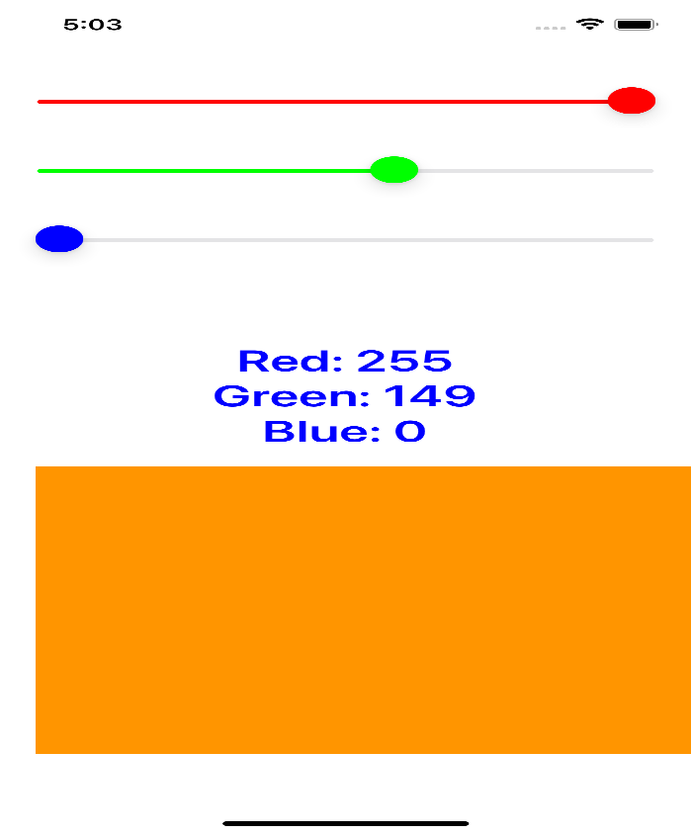

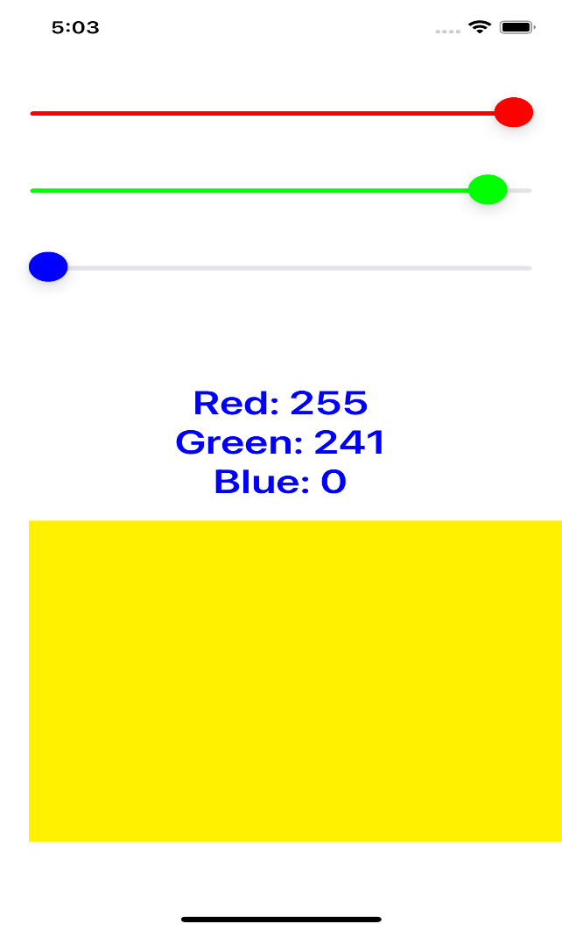 

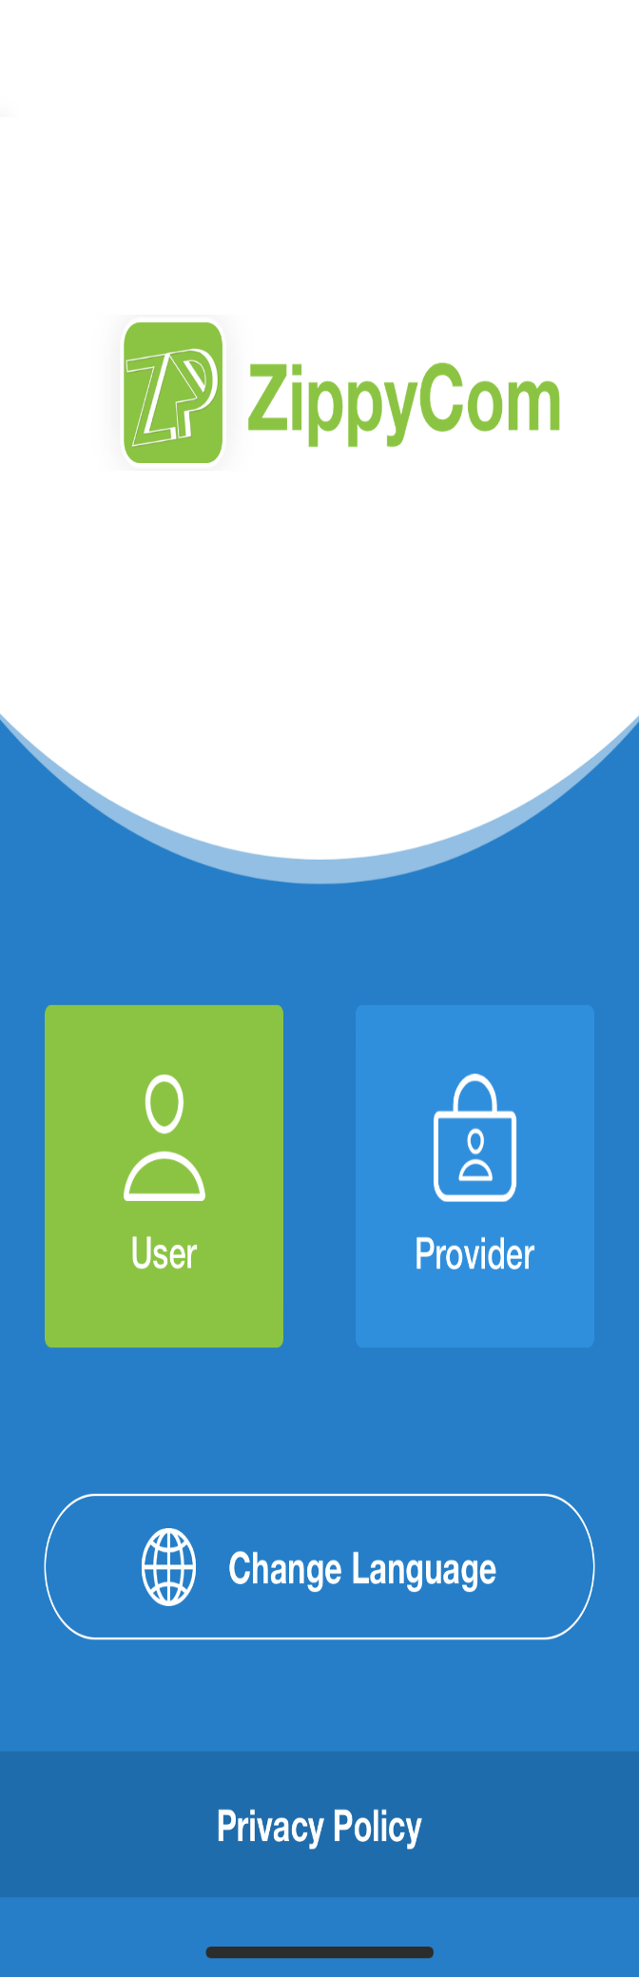 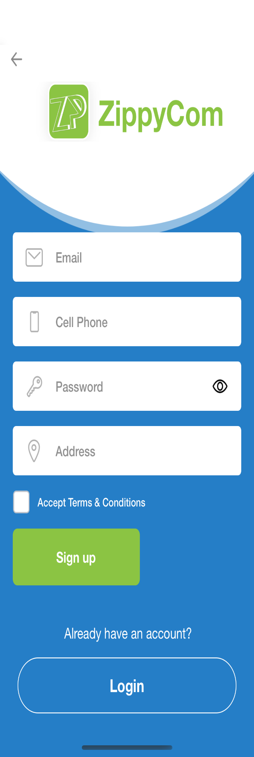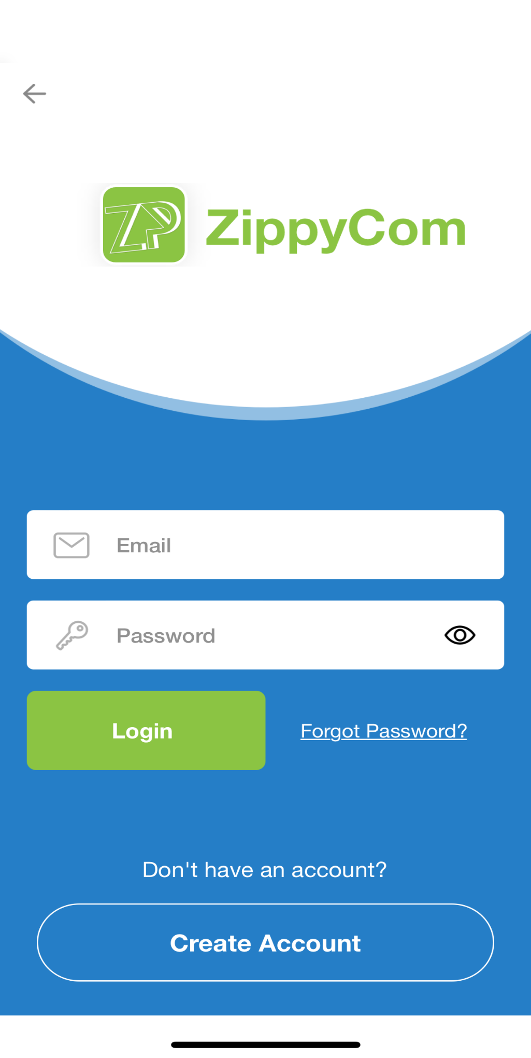

**Chapter: 3 - TOOLS AND TECHNOLOGY USED**

* **Hardware Requirements**

* M2 Mac Mini
* 8 GB RAM
* 256 GB SSD
* IOS Platform
* **Software Requirements**
* Tool: code
* Front-End: IOS using Swift
* Operating System Name: XCode

**Chapter: 4 - OBSERVATIONS**

* Experience shows that the Swift programming language is suitable for both mobile application development and programming teaching. The main advantages of the language include its simplicity, modern features, simple and clear libraries.
* Another advantage is that Swift belongs to the Open Source category. Apple not only cares about the quality of the programming language but also offers many resources for teaching programming.
* The company is aware of the need to devote sufficient energy to support programming teaching. Experience to date has shown that Swift is popular with students and children alike.

**Chapter: 5 - CONCLUSION**

* Swift is a hybrid programming language that uses object-oriented, procedural and some functional features. Currently, it appears to be the most appropriate language for developing native mobile applications and systems for iOS, watchOS and tvOS. Despite rapid development and occasional backward compatibility issues. Experience and measurements show that Swift is a fast and safe language.
* Swift code is up to a third shorter than Objective-C, which leads to more rapid, clearer but also safer code creation. Experiments with students show that Swift is easier to read for students than Objective-C or C++. Due to the short existence of Swift, there are, of course, problems with rapid development and language changes, less support and a wealth of libraries, frameworks and development environments.
* Swift does not bring new programming approaches, but its creators have tried to incorporate it and combine the best features we can have in a specific range in other programming languages. For example, Closures (JavaScript), Generics (Java), Tuples (Python), Operator Overloading (C++), Optional types (Haskell), Protocols (Java) etc. Experience shows that the Swift programming language is suitable for teaching programming. Students can work with Swift programming language very well. The simplicity and structure of the programming language contribute to a quick understanding of the language.

**REFERENCES**

1. David, T.: The Comparison Between Swift and Java Programming Language, Bachelor thesis, University of Ostrava (2018)
2. García, C. G., Espada, J. P., Pelayo G-Bustelo, B. C., Cueva Lovelle, J. M.: Swift vs. Objective-C: A New Programming Language, International Journal of Interactive Multimedia and Artificial Intelligence, https://pdfs.semanticscholar.org/a709/2e9eaf0490c3ff2982abf925dd0d7cf01220.pdf (2015)
3. Kinley, K.: Apple’s Swift programming language is now top tier, https://www.wired.com/story/apples-swift-programminglanguage-is-now-top-tier/, last accessed 2018/03/18
4. Prechelt, L.: An Empirical Comparison of Seven Programming Languages, Computer, Volume 33, Issue 10, Oct 2000, ISSN 0018-9162 (2000)
5. Ray, B., Posnett, D., Filkov, V., Devanbu, P.: A Large Scale Study of Programming Languages and Code Quality in Github, Communications of the ACM, Volume 60, Number 10, Pages 91-100, ISSN 0001-0782 (2017)
6. Schmieder, A.: Swift, C++ Performace, http://www.primatelabs.com/blog/2014/12/swift-performance/ (2014)